深 圳 大 学 实 验 报 告

课程名称： python语言程序设计

实验项目名称： 实验7 - 类

学院： 医学部生物医学工程学院

专业： 生物医学工程

指导教师： 黄淦

报告人： 陈嘉鸿

学号： 2021220049

实验时间： 2023年 4 月 16 日

教务处制

- 实验内容
Exercise 1: Rational numbers
In this problem, we will write a class that can represent rational numbers, i.e. fractions p/q.
(a) Create a class Rational which is initialized by two integers, p and q, the nominator and denominator
(b) Add a method to print the rational number as p/q (the __str__ or __repr__ method is useful).
(c) We would like to represent 10/20 by 1/2 instead, hence write a function that
computes the greatest common divisor, and ensure that every rational number is
simplified
(d) Add a method so that we can add two rational numbers with r1 + r2, here the
__add__() method is useful.
(e) Add a method to subtract two rational numbers. (__sub__)
(f) Add a method to multiply two rational numbers. (__mul__)
(g) Add a method to divide two rational numbers. (__div__)
(h) Add a method that compares whether two rational numbers are equal.
(i) Add a method to convert the rational number to a floating point (the __float__()
method maybe handy).
Exercise 2: Sparse and dense vectors
Let's implement class which contain some vector functions. There are two types of
vectors, normal or dense vectors, which we can represent using lists. For sparse vectors, where many of the elements are zero, this is inefficient. Instead, we use a dictionary with keys the indices of non-zero values, and then the value corresponding to the key is the value of the vector at that index. Hence, the vector [1; 2; 4] can be stored as a list: [1, 2, 4] or as a dictionary {0:1, 1: 2, 2: 4}.
we would like to represent sparse and dense vectors as classes, this way we can overload operators such as + ( add ) and get sensible output. For example, using + on two dense vectors implemented as lists would append the second vector to the first, instead of adding the two together.
Implement sparse and dense vectors. Both classes should have the following
capabilities:
(a) Print vector
(b) Add two vectors (both if other is dense and sparse)
(c) Multiply two vectors (both if other is dense and sparse)
Hint: isinstance() might be useful.

- 代码实现过程
Exercise 1
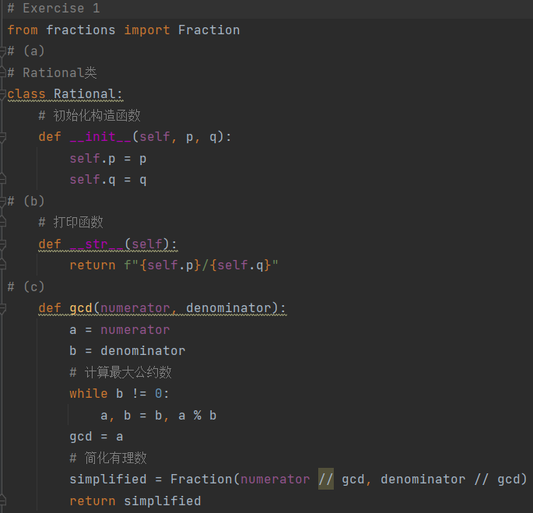
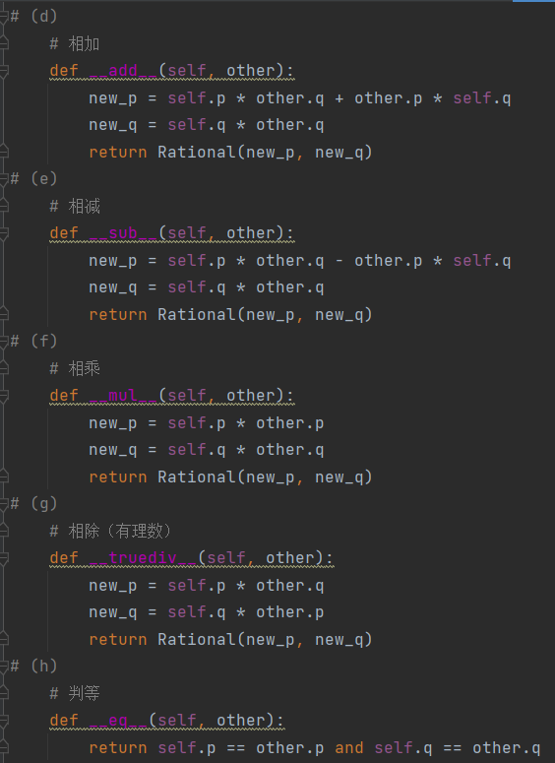
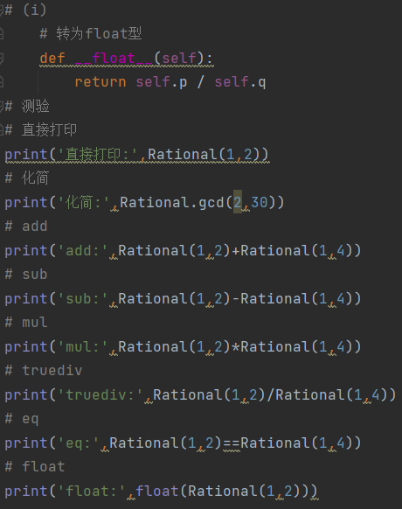
Exercise 2
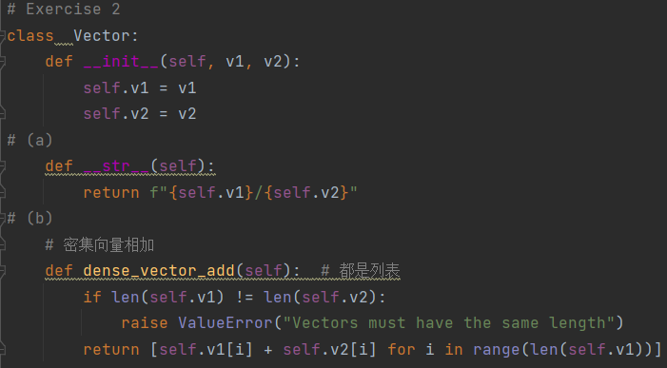
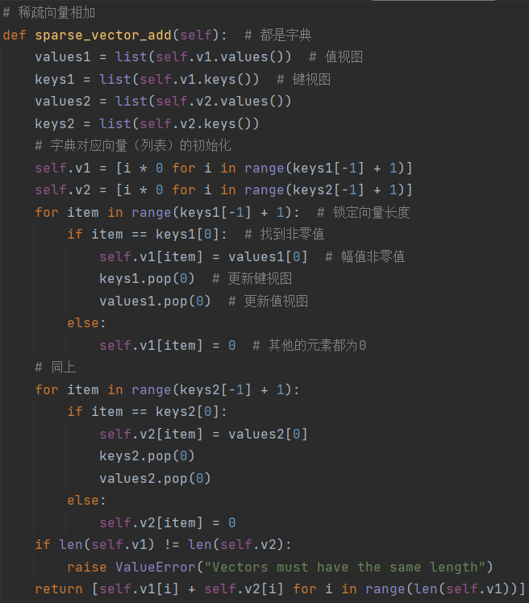
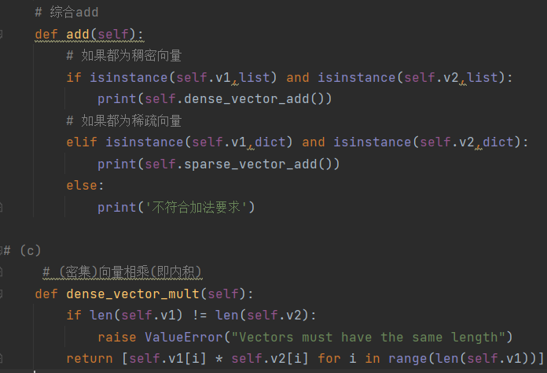
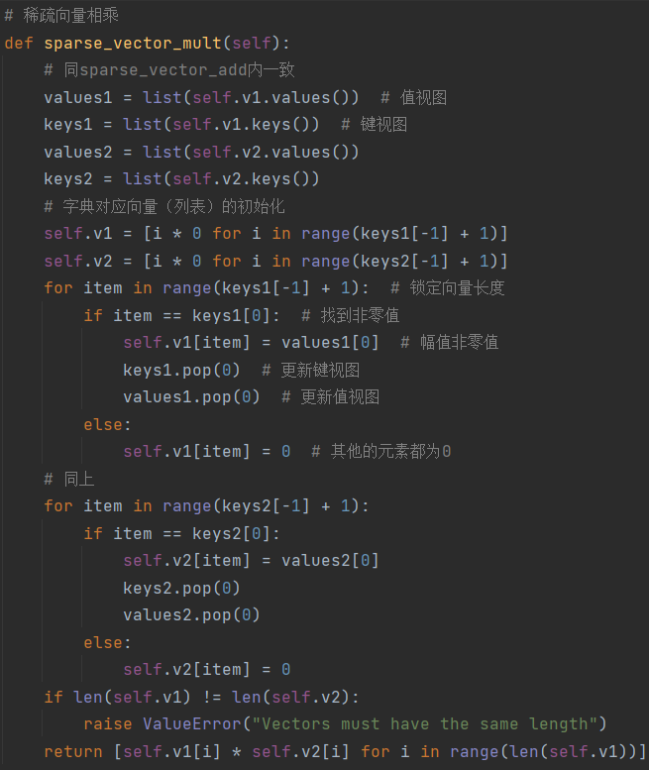
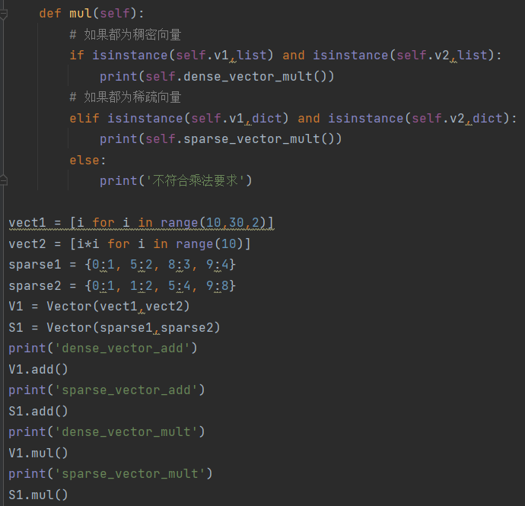
- 运行结果
Exercise 1
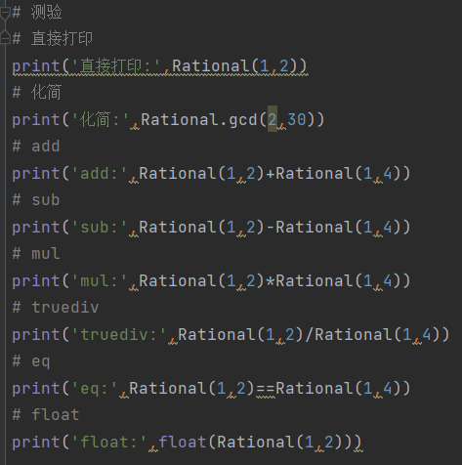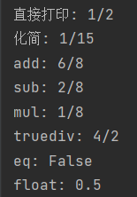
Exercise 2
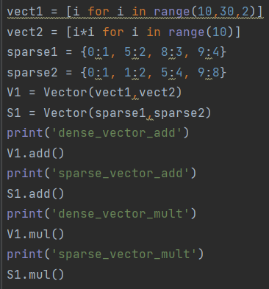
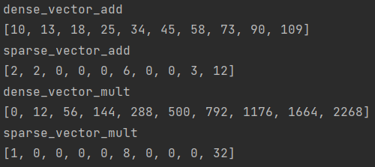

- 任务实现中遇到的问题以及解决方法。
问题1：化简步骤很低效繁琐
解决办法：使用fractions函数，实现化简有理数
问题2：稀疏向量的计算
解决办法：使用字典来表示稀疏向量，键为数，值为量，可以通过keys和values来实现对其键值对的计算。

问题3：Exercise 2中多种加法和乘法，要根据输入的向量稠密还是稀疏自己选用函数的话既麻烦又不够人性化
解决办法：创建实例函数，使用isinstance()判断两个是否为稠密或者稀疏向量，根据判断选择方法来实现加法或乘法，不符合条件则输出语句。

- 实验结论：
通过本次实验，学习了类与对象的计算机及python知识，手写代码实现了实验任务，加深对类与对象的理解，同时在代码实验中不断纠错和改进优化代码，强化了自己的代码能力。
指导教师批阅意见：
- 实验报告的完整性：
□实验报告完整
□实验报告不够完整
□实验报告缺少内容
- 实验结果的正确性
□实验结果正确无误，
□有小的逻辑错误
□代码有很大错误
- 代码的简洁和效率
□代码简洁优雅，可读性好，能高效运行
□代码具有较好的可读性，但执行效率可进一步优化
□代码可读性不佳，执行效率较好
□代码混乱，效率不佳
成绩评定：

指导教师签字：

2022年 0x 月 xx 日
备注：

